##### **XYZ Ads Airing Report Analysis**



**Report By**

**Aditya Shekhar**

**Contents:-**

1. **Project Description**
2. **Tech-stack used**
3. **Insights**
4. **Conclusion**
5. **Result**
6. **Project Description**

 In this project I am given a dataset having different TV Airing Brands, their product, their category. Dataset includes the network through which Ads are airing,  types of network like Cable/ Broadcast and the show name also on which Ads got aired. IT also includes other data like Pod Position (the lesser the valuable), duration for which Ads aired on screen, Equivalent sales &, total amount spent on the Ads aired.

**Business Understanding:**

Advertising is a way of marketing your business in order to increase sales or make your audience aware of your products or services. Until a customer deals with you directly and actually buys your products or services, your advertising may help to form their first impressions of your business. Target audience for businesses could be local, regional, national or international or a mixture. So they use different ways for advertisement. Some of the types of advertisement are: Internet/online directories, Trade and technical press, Radio, Cinema, Outdoor advertising, National papers, magazines and TV. Advertising business is very competitive as a lot of players bid a lot of money in a single segment of business to target the same audience. Here comes the analytical skills of the company to target those audiences from those types of media platforms where they convert them to their customers at a low cost.

1. **Tech-Used**

Ms Excel



Microsoft Excel is a spreadsheet developed by Microsoft for Windows, macOS, Android and iOS. It features calculation or computation capabilities, graphing tools, pivot tables, and a macro programming language called Visual Basic for Applications. Excel forms part of the Microsoft Office suite of software.

1. **What is Pod Position? Does the Pod position number affect the amount spent on Ads for a specific period of time by a company?**

Pod position is the order of ad showed in any TV show advertisement section, lesser the pod position higher its value.

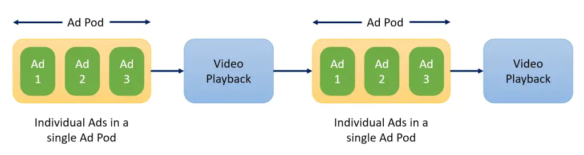

Four reasons why advertisers and publishers use ad pods

1 .They offer more control

Ad pods help advertisers avoid running ads alongside direct competitors, ensuring that their offering

stands out to viewers and that their message doesn’t get saturated.

2. Ad pods offer a better way to monetize long-form content

Publishers with longer-form content can leverage the controls offered by ad podding to set up more

advanced monetization strategies for their streaming content.

3. Ad pods allow publishers to meet buyers’ needs

Without an ad pod in place, advertisers have historically been spinning a wheel of chance when they

bought into streaming apps on CTV. They have had very little control over frequency or the position of

their ad within the ad break.

4. Ad pods improve the user experience

Ad pods enable a better user experience because the ads are tailored to viewers’ preferences.

**Example:**

Suppose you're streaming Brooklyn 99 on Hulu and halfway through the episode an ad break starts.

You watch three different ads back-to-back, and then the episode resumes. You just sat through an ad

pod.

From the given dataset -

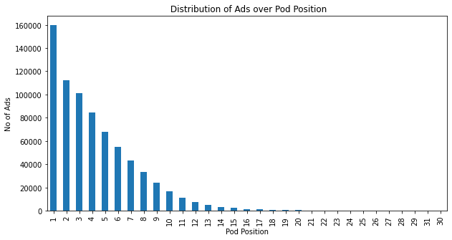

Most of Ads are advertised on 1st pod position, as every business wants to create first impression on the audience in order to increase their sales.

**Yes,** the pod position number do affect the amount spent on ads for a specific period of time by a company because lesser the pod position higher its value. We can see this through an example from the dataset –

The highest amount that has been spent on adds are for the pod positions 1 to 6. As the pod position increases the amount spent on the adds decrease.

|  |  |  |
| --- | --- | --- |
| **Pod Position** | **Sum of Spend ($)** | **Count of Spend ($)** |
| 31 | 3008 | 3 |
| 30 | 48 | 2 |
| 29 | 2031 | 4 |
| 28 | 757 | 5 |
| 27 | 15633 | 15 |
| 26 | 108641 | 28 |
| 25 | 37872 | 48 |
| 24 | 77874 | 75 |
| 23 | 117743 | 106 |
| 22 | 249062 | 189 |
| 21 | 321843 | 235 |
| 20 | 524109 | 347 |
| 19 | 939675 | 511 |
| 18 | 1229739 | 735 |
| 17 | 1696001 | 1038 |
| 16 | 2542312 | 1465 |
| 15 | 4075787 | 2243 |
| 14 | 6666590 | 3365 |
| 13 | 9189860 | 4942 |
| 12 | 14044029 | 7373 |
| 11 | 19755483 | 11136 |
| 10 | 28706471 | 16723 |
| 9 | 41909147 | 24324 |
| 8 | 58205928 | 33367 |
| 7 | 77255099 | 43161 |
| 6 | 105981319 | 55059 |
| 5 | 132148569 | 67597 |
| 4 | 178545699 | 84430 |
| 3 | 196432582 | 101340 |
| 2 | 187654622 | 112257 |
| 1 | 324025029 | 159661 |
| **Grand Total** | **1392462562** | **731784** |

1. **What is the share of various brands in TV airings and how has it changed from Q1 to Q4 in 2021?**

Share of various brands in TV airings -

I am Using Pivot table and Pivot table Pie Chart to determine the share of various brands in TV airings.

|  |  |
| --- | --- |
| **Brands** | **Share of Brands** |
| Honda Cars | 85265 |
| Hyundai Motors India | 71296 |
| Mahindra and Mahindra | 147890 |
| Maruti Suzuki | 280274 |
| Tata Motors | 81041 |
| Toyota | 66018 |
| **Grand Total** | **731784** |

**Changes**

|  |  |  |  |  |  |
| --- | --- | --- | --- | --- | --- |
| **Car Brands** |  |  |  |  |  |
|  | **Q1** | **Q2** | **Q3** | **Q4** | **Grand Total** |
| Honda Cars | 25929 | 19388 | 23020 | 16928 | 85265 |
| Hyundai Motors India | 22396 | 18623 | 16484 | 13793 | 71296 |
| Mahindra and Mahindra | 43371 | 46244 | 39537 | 18738 | 147890 |
| Maruti Suzuki | 82381 | 71695 | 66196 | 60002 | 280274 |
| Tata Motors | 20679 | 14967 | 14912 | 30483 | 81041 |
| Toyota | 18212 | 22083 | 19678 | 6045 | 66018 |
| **Grand Total** | **212968** | **193000** | **179827** | **145989** | **731784** |

* In almost all the quarters Maruti Suzukihas highest share.
* Considering all the quarters, 1st Quarter has highest share and it orderly decreased

in quarter 4.

* There is a fall from Quarter 1 to Quarter 4.

1. **Conduct a competitive analysis for the brands and define advertisement strategy of different brands and how it differs across the brands.**

A **competitive analysis** is an assessment of your competitors’ products, services and sales tactics, evaluating their strengths and weaknesses relative to your own. It’s good business practice to conduct a full competitive analysis at least once a year.

Competitor Analysis play an important role in the strategic planning process and company success. To be able to effectively gain an understanding of the Auto market, it is key to have an in-depth knowledge of your competitors. The better that you understand the competition of your industry, the more effective the strategies & implementation you can make to compete with them.

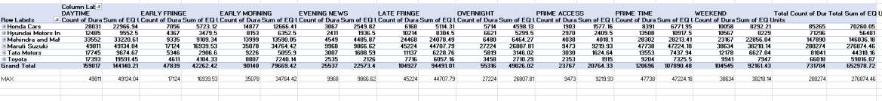

* In this Competitive Analysis, every one have unique idea.
* In this analysis, I considered columns, (Dayparts, Duration, Brand, EQ Units , Brand Months as Quarters).
* Here the almost all the brands advertise all their products in all the Day Parts.
* But Maruti Suzuki advertise their products in all their day parts, with high duration.
* So the Equivalent Sales are high for this Brand.
* Maruti Suzuki have a different strategy , means engaging people in all the day parts with high

duration ads, which makes more profit for them.

* Other Brands can also use this type of strategies for their growth.

1. **Mahindra and Mahindra wants to run a digital ad campaign to complement its existing TV ads in Q1 of 2022. Based on the data from 2021, suggest a media plan to the CMO of Mahindra and Mahindra. Which audience should they target?**

**Media Plan -** A media plan describes which audience will be targeted, across which channels, at what time, and with which message. An effective media plan will result in a set of advertising opportunities that target a specific audience and fit in with the organization's marketing budget.

The elements of media planning include understanding marketing objectives, setting campaign goals, performing market research, managing a budget, structuring media objectives to establish a media planning strategy, creating a media plan, implementing the plan and evaluating the results of the plan.

In this media plan I am using data from given dataset. For Budget I am using the money used by mahidra and mahindra for 2021 marketing.

Mahindra Thar is the most valueable product for Mahindra. So, They must target Mahindra Thar audience.

|  |  |  |  |  |  |  |  |
| --- | --- | --- | --- | --- | --- | --- | --- |
| **Count of Broadcast Month** | **Brand** |  |  |  |  |  |  |
| **Pod Position** | **Honda Cars** | **Hyundai Motors India** | **Mahindra and Mahindra** | **Maruti Suzuki** | **Tata Motors** | **Toyota** | **Grand Total** |
| 1 | 9.12% | 9.10% | 16.35% | 47.50% | 10.21% | 7.72% | 100.00% |
| 2 | 11.91% | 11.20% | 19.04% | 37.83% | 10.76% | 9.26% | 100.00% |
| 3 | 11.67% | 10.46% | 20.78% | 35.93% | 11.38% | 9.78% | 100.00% |
| 4 | 11.97% | 9.79% | 21.62% | 34.76% | 11.33% | 10.54% | 100.00% |
| 5 | 11.84% | 9.18% | 22.50% | 34.17% | 11.60% | 10.70% | 100.00% |
| 6 | 11.88% | 9.03% | 22.81% | 34.25% | 11.76% | 10.28% | 100.00% |
| 7 | 12.09% | 8.76% | 23.92% | 34.30% | 11.50% | 9.43% | 100.00% |
| 8 | 12.70% | 8.98% | 23.16% | 35.35% | 11.74% | 8.07% | 100.00% |
| 9 | 13.41% | 8.75% | 22.40% | 36.93% | 11.39% | 7.12% | 100.00% |
| 10 | 13.78% | 9.14% | 21.68% | 37.67% | 11.56% | 6.17% | 100.00% |
| 11 | 14.03% | 10.17% | 19.94% | 38.15% | 11.25% | 6.47% | 100.00% |
| 12 | 15.57% | 10.73% | 18.64% | 37.76% | 11.28% | 6.02% | 100.00% |
| 13 | 16.61% | 11.92% | 18.35% | 37.03% | 10.02% | 6.07% | 100.00% |
| 14 | 16.79% | 12.48% | 18.25% | 35.45% | 11.17% | 5.85% | 100.00% |
| 15 | 21.00% | 11.50% | 16.94% | 35.71% | 8.65% | 6.20% | 100.00% |
| 16 | 22.05% | 11.60% | 15.70% | 36.31% | 9.15% | 5.19% | 100.00% |
| 17 | 24.76% | 11.66% | 14.84% | 32.27% | 10.98% | 5.49% | 100.00% |
| 18 | 26.12% | 10.20% | 15.92% | 28.71% | 12.24% | 6.80% | 100.00% |
| 19 | 26.42% | 11.15% | 15.07% | 31.12% | 9.00% | 7.24% | 100.00% |
| 20 | 31.41% | 9.51% | 9.80% | 30.84% | 12.97% | 5.48% | 100.00% |
| 21 | 31.06% | 11.06% | 13.62% | 27.66% | 11.06% | 5.53% | 100.00% |
| 22 | 37.04% | 6.88% | 9.52% | 28.57% | 11.64% | 6.35% | 100.00% |
| 23 | 33.96% | 7.55% | 16.98% | 25.47% | 7.55% | 8.49% | 100.00% |
| 24 | 30.67% | 5.33% | 28.00% | 20.00% | 14.67% | 1.33% | 100.00% |
| 25 | 43.75% | 10.42% | 14.58% | 10.42% | 16.67% | 4.17% | 100.00% |
| 26 | 25.00% | 0.00% | 21.43% | 39.29% | 10.71% | 3.57% | 100.00% |
| 27 | 46.67% | 0.00% | 0.00% | 20.00% | 26.67% | 6.67% | 100.00% |
| 28 | 40.00% | 0.00% | 20.00% | 20.00% | 20.00% | 0.00% | 100.00% |
| 29 | 25.00% | 25.00% | 25.00% | 25.00% | 0.00% | 0.00% | 100.00% |
| 30 | 50.00% | 0.00% | 0.00% | 0.00% | 50.00% | 0.00% | 100.00% |
| 31 | 33.33% | 0.00% | 33.33% | 33.33% | 0.00% | 0.00% | 100.00% |
| **Grand Total** | **11.65%** | **9.74%** | **20.21%** | **38.30%** | **11.07%** | **9.02%** | **100.00%** |

* ▪ In the table , Rows – Pod position Column – Brand Values – Count of Broadcast Month Filters –Quarters.
* ▪ We can see Maruti Brand Hits highest and Valuable Position.
* ▪ Mahindra company should telecast and use all day parts for advertising, so that it will be a good growth for them in the year 2023.

**Conclusion**

After Analysing all the data , I have drawn few insights from the analysis.

* Pod position is a sequence of ads.
* The share value is high in Quarter 1 and low in Quarter 4.
* Maruti Suzuki telecasts the advertisements in almost all day parts.
* Mahindra and Mahindra should telecast their advertisements in almost all parts , so that it can be a good growth start for the year 2023.

**Result**

After doing this project I have a very good understanding of how a company run their ads, how they target their audience, how much they spend on ads, what is pod position and it affect these company budget. This is a tough project. I have done a lot of research to understand the question and find their answers from the dataset.